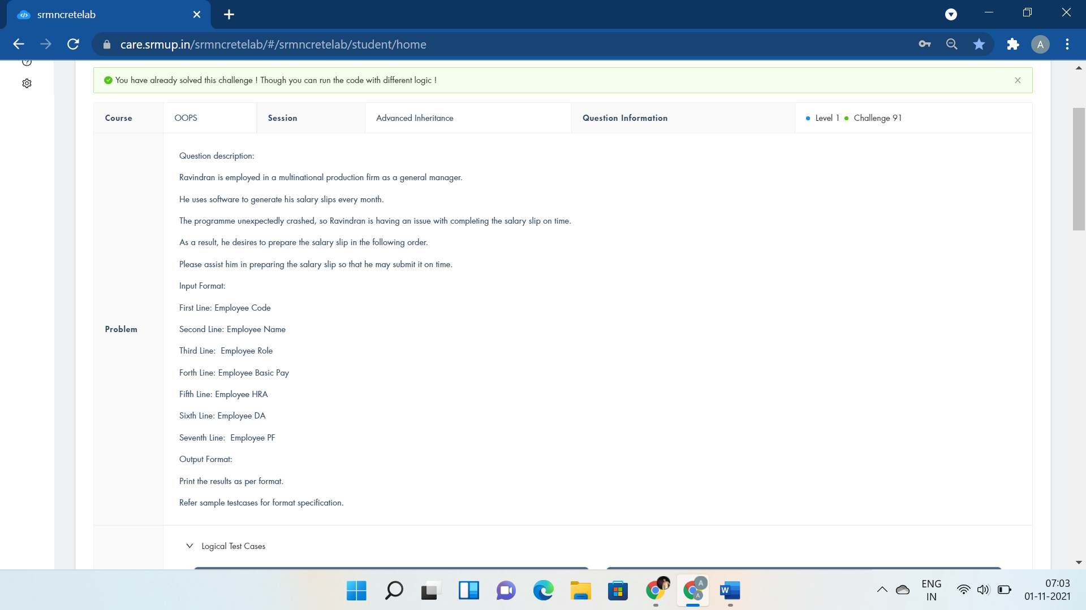

#include <iostream>

using namespace std;

class Employee{

public:

};

class Salary : public Employee{

public:

int code,basic,hra,da,pf,total;

string name,position;

void getEmpDetails(){

cin>>code>>name>>position;

}

void getPayDetails(){

cin>>basic>>hra>>da>>pf;

}

void calculate(){

total=basic+hra+da-pf;

}

void display(){

cout<<"Employee Number:"<<code<<endl;

cout<<"Employee Name:"<<name<<endl;

cout<<"Employee Role:"<<position<<endl;

cout<<"Employee Net Pay:"<<total<<endl;

}

};

int main()

{

Salary s;

s.getEmpDetails();

s.getPayDetails();

s.calculate();

s.display();

return 0;

}

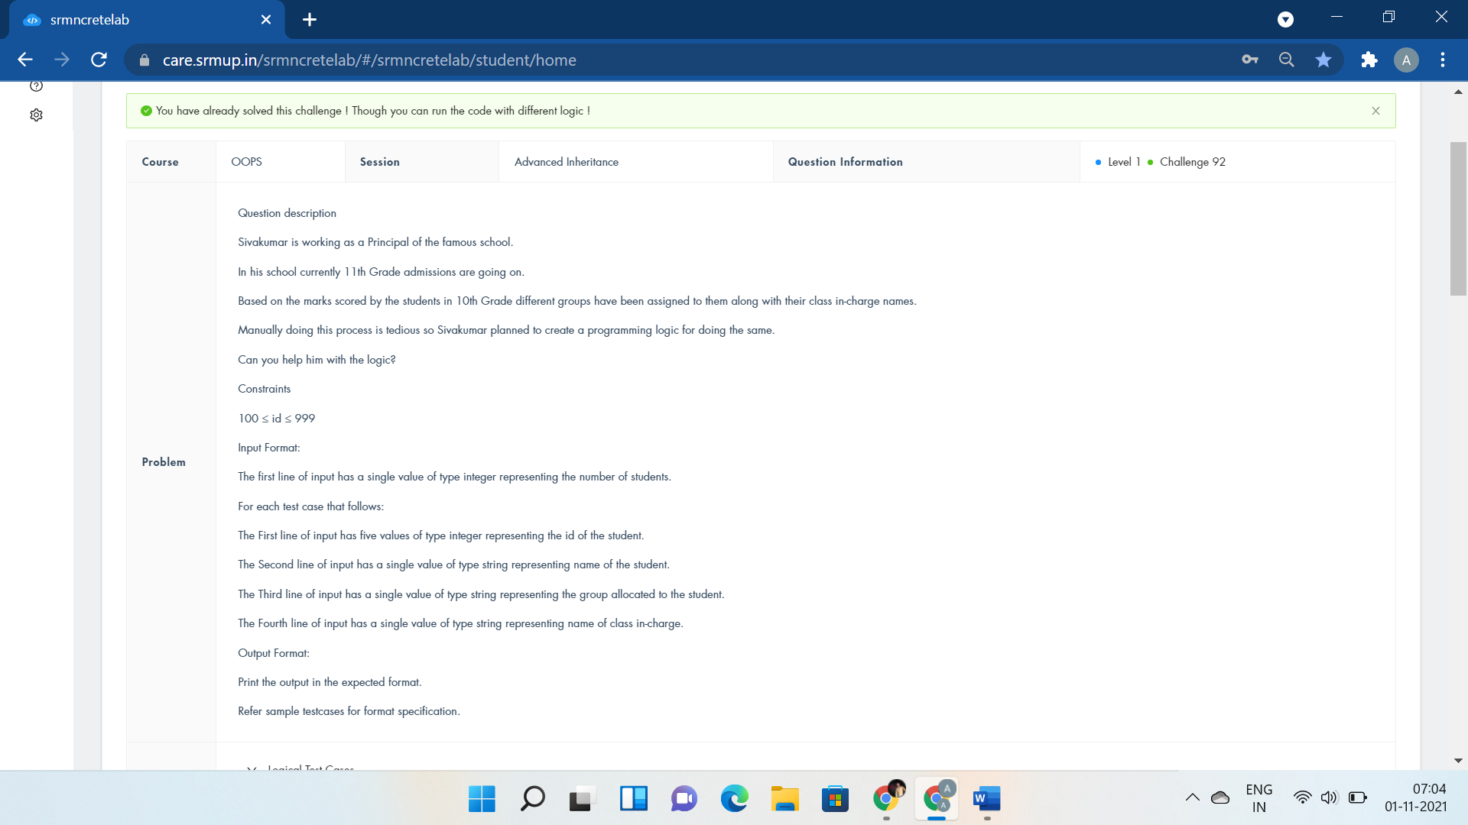

#include <iostream>

using namespace std;

class Person{

};

class Teaching : public Person{

};

class Instructor : public Teaching{

public:

int id;

string name,group,staff;

void accept_instructor_details(){

cin>>id>>name>>group>>staff;

}

void display_instructor_details(){

cout<<"Id:"<<id<<endl;

cout<<"Name:"<<name<<endl;

cout<<"Group:"<<group<<endl;

cout<<"Staff:"<<staff<<endl;

}

};

int main()

{

int n;

cin>>n;

Instructor inst[n];

for(int i=0;i<n;i++){

inst[i].accept_instructor_details();

inst[i].display_instructor_details();

}

return 0;

cout<<"Instructor *inst;";

}

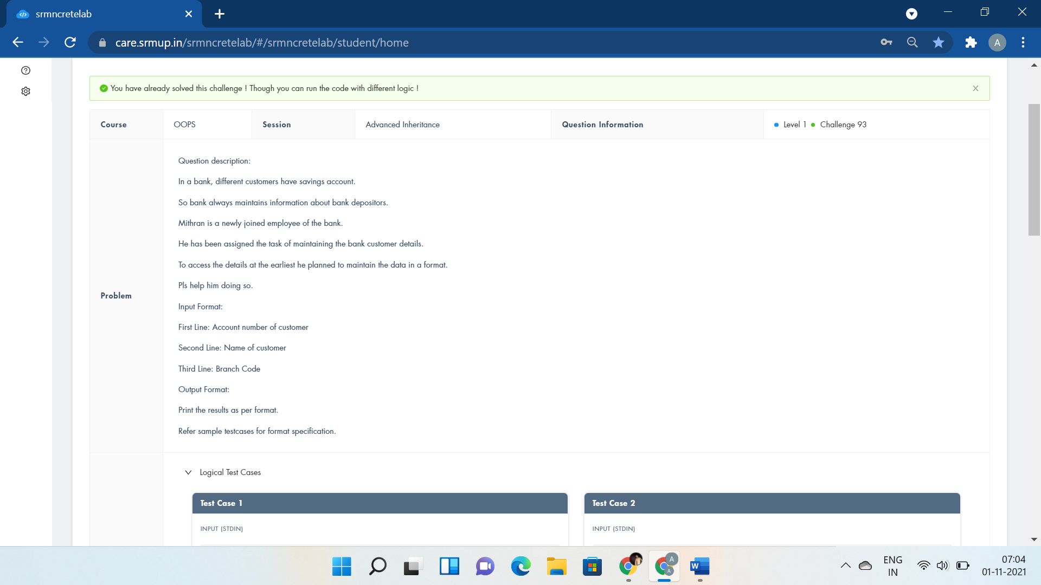

#include <iostream>

using namespace std;

class acc{

public:

int no;

void getacc(){

cin>>no;

}

};

class branch:public acc{

public:

string name;

int code;

void getbranch(){

cin>>name>>code;

}

void display(){

cout<<"Acc No:"<<no<<endl;

cout<<"Name:"<<name<<endl;

cout<<"Branch Code:"<<code<<endl;

}

};

int main()

{

branch b;

b.getacc();

b.getbranch();

b.display();

return 0;

}



#include <iostream>

using namespace std;

class Food{

};

class Nutritionist:public Food{

};

class Patient:public Nutritionist{

public:

float cal,fat;

void calorie(){

cin>>cal>>fat;

}

void dplan(){

if(cal<fat)

cout<<"Fatgrams cannot be less than 0 or greater than calories"<<endl;

cout<<"Calories from fat: "<<fat*9/cal*100<<"%";

}

};

int main()

{

Patient p;

p.calorie();

p.dplan();

return 0;

}



#include <iostream>

using namespace std;

class Sam{

};

class Robin:public Sam{

public:

int rows;

void read(int y){

rows=y;

}

void display(){

for(int i=0;i<rows;i++){

for(int j=0;j<rows;j++){

cout<<"* ";

}

cout<<endl;

}

}

};

int main()

{

Robin obj;

int y;

cin>>y;

obj.read(y);

obj.display();

return 0;

}



#include <iostream>

using namespace std;

class student{

public:

int roll,m1,m2;

void get(){

cin>>roll>>m1>>m2;

}

};

class sports{

public:

int sp;

void getsm(){

cin>>sp;

}

};

class statement : public student, public sports{

public:

void display(){

cout<<"Roll No:"<<roll<<endl;

cout<<"Total:"<<m1+m2+sp<<endl;

cout<<"Average:"<<(m1+m2+sp)/3<<endl;

}

};

int main()

{

statement obj;

obj.get();

obj.getsm();

obj.display();

return 0;

}



#include <iostream>

using namespace std;

class Shape{

public:

int len,wid;

void input(int l,int b){

len=l;

wid=b;

}

};

class Rectangle: public Shape{

public:

void output(){

cout<<len*wid<<endl;

}

};

class Triangle: public Shape{

public:

void output(){

//if((len*wid)%2==0)

cout<<0.5*len*wid<<endl;

//else

//cout<<len*wid/2+1<<endl;

}

};

int main()

{

int l,b;

cin>>l>>b;

Rectangle rect;

Triangle tri;

rect.input(l,b);

tri.input(l,b);

rect.output();

tri.output();

return 0;

}

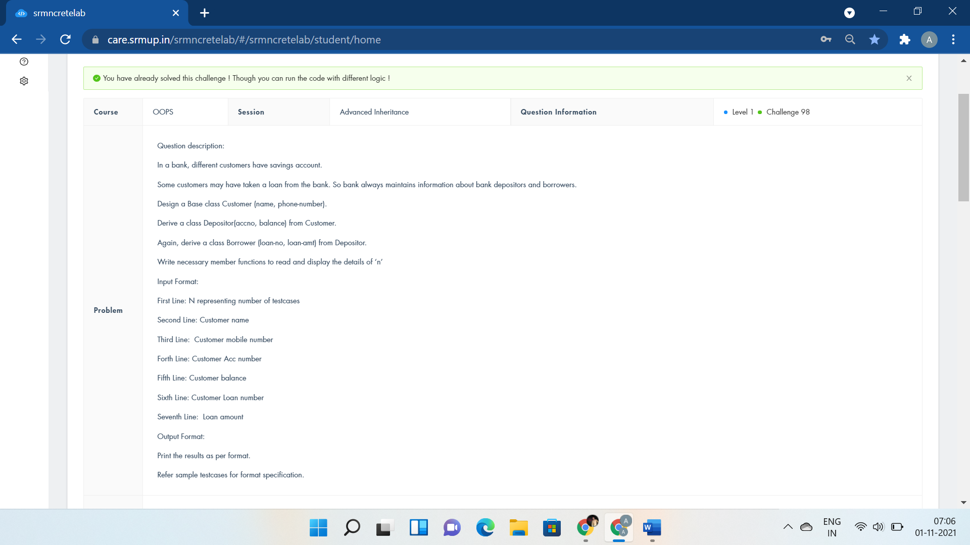

#include <iostream>

using namespace std;

class customer{

public:

int no;

long long int mobile;

string name;

void acceptc(){

cin>>name>>mobile>>no;

}

};

class deposit:public customer{

public:

int bal;

void acceptd(){

cin>>bal;

}

void dispd(){

cout<<"Customer Name:"<<name<<endl;

cout<<"Customer Phone No:"<<mobile<<endl;

cout<<"Customer A/c No:"<<no<<endl;

cout<<"Balance:"<<bal<<endl;

}

};

class borrow:public deposit{

public:

long long int loan_no,amt;

void acceptb(){

cin>>loan_no>>amt;

}

void dispb(){

cout<<"Loan No:"<<loan_no<<endl;

cout<<"Loan Amount:"<<amt<<endl;

}

};

int main()

{

int n;

cin>>n;

borrow b1[n];

for(int i=0;i<n;i++){

b1[i].acceptc();

b1[i].acceptd();

b1[i].acceptb();

b1[i].dispd();

b1[i].dispb();

}

return 0;

}



#include <iostream>

using namespace std;

class Receive{

public:

int r1,i1,r2,i2,r3,i3;

void getdata(){

cin>>r1>>i1>>r2>>i2;

}

};

class Operate : public Receive{

public:

void add(){

r3=r1+r2;

i3=i1+i2;

}

};

class Present :public Operate{

public:

void output(){

cout<<r1<<"+"<<i1<<"i"<<endl;

cout<<r2<<"+"<<i2<<"i"<<endl;

cout<<r3<<"+"<<i3<<"i"<<endl;

}

};

int main()

{

Present calc;

calc.getdata();

calc.add();

calc.output();

return 0;

}

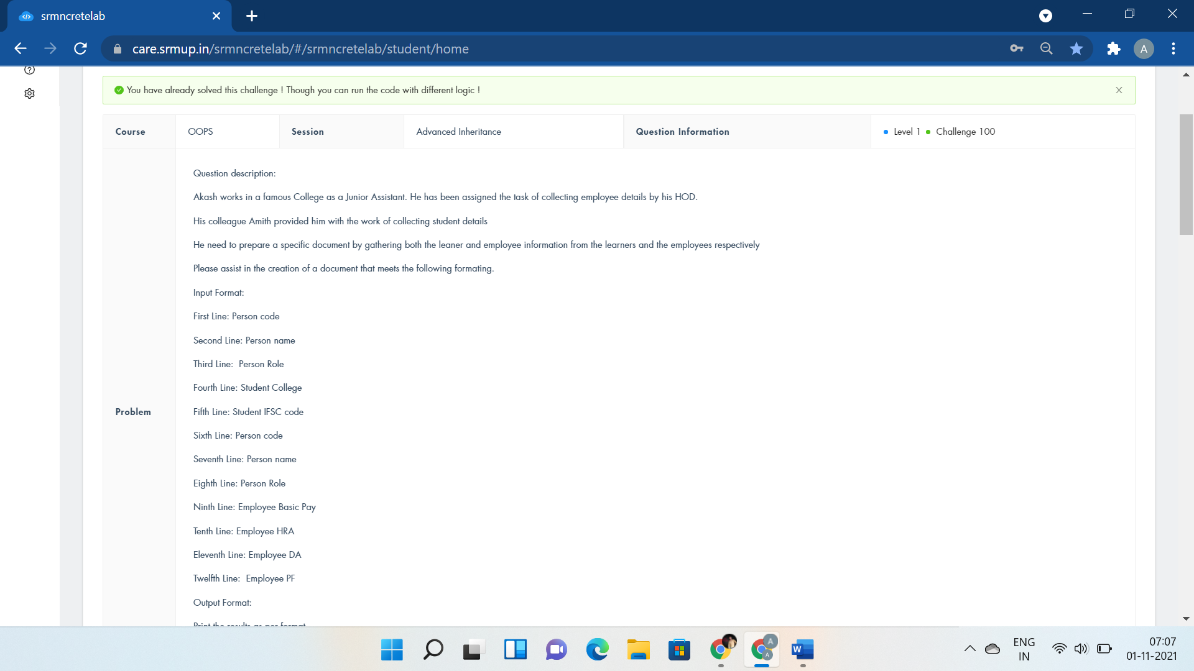

#include <iostream>

using namespace std;

class Person{

};

class Employee : private Person{

};

class Student : private Person{

public:

int n1,n2,basic,hra,da,pf;

string name1,role1,col,ifsc,name2,role2;

void getdetail(){

cin>>n1>>name1>>role1>>col>>ifsc>>n2>>name2>>role2;

}

void getEmployeeDetails(){

cin>>basic>>hra>>da>>pf;

}

void student_display(){

cout<<"Person number:"<<n1<<endl;

cout<<"Person name:"<<name1<<endl;

cout<<"Person Role:"<<role1<<endl;

cout<<"Student college Name:"<<col<<endl;

cout<<"Student IFSC:"<<ifsc<<endl;

cout<<"Person number:"<<n2<<endl;

cout<<"Person name:"<<name2<<endl;

cout<<"Person Role:"<<role2<<endl;

}

void employee_display(){

cout<<"Employee Basic pay:"<<basic<<endl;

cout<<"Employee HRA:"<<hra<<endl;

cout<<"Employee DA:"<<da<<endl;

cout<<"Employee PF:"<<pf<<endl;

cout<<"Employee Net Pay:"<<basic+hra+da-pf<<endl;

}

};

int main()

{

Student e;

e.getdetail();

e.getEmployeeDetails();

e.student_display();

e.employee_display();

return 0;

cout<<"s.student_display();";

}